**Ivory Coast country profile**

Published

15 January 2019

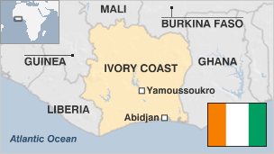

**For more than three decades after its independence from France, Ivory Coast was known for its religious and ethnic harmony, as well as its well-developed economy.**

The Western African country was hailed as a model of stability. But an armed rebellion in 2002 split the nation in two. Since then, peace deals alternated with renewed violence as the country slowly edged its way towards a political resolution of the conflict.

Despite the instability, Ivory Coast is the world's largest exporter of cocoa beans, and its citizens enjoy a relatively high level of income compared to other countries in the region.

* Read [more country profiles](http://news.bbc.co.uk/1/hi/country_profiles/) - Profiles by [BBC Monitoring](http://www.bbc.co.uk/monitoring)

**President : Alassane Ouattara**

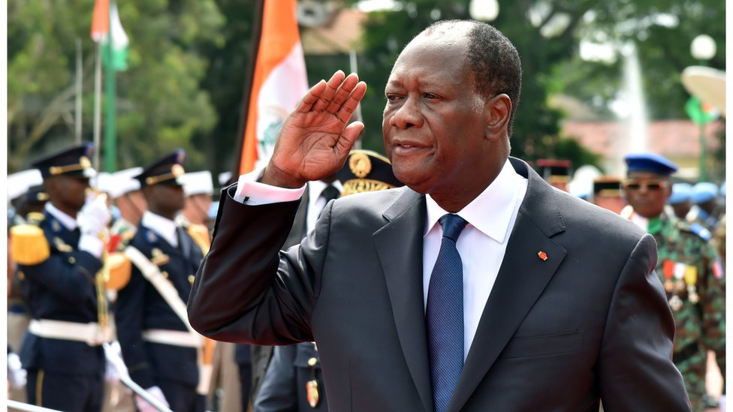image copyrightGetty Images

Alassane Ouattara has been in power since his predecessor, Laurent Gbagbo, was forcibly removed from office after refusing to accept Mr Ouattara's internationally recognised victory in the November 2010 presidential election.

In 2015, Mr Ouattara won a second five-year term with nearly 84% of the vote, in an election described as credible by US observers.

A US-educated economist from the Muslim north, Mr Ouattara served as President Felix Houphouet-Boigny's last prime minister after a long career at the International Monetary Fund.

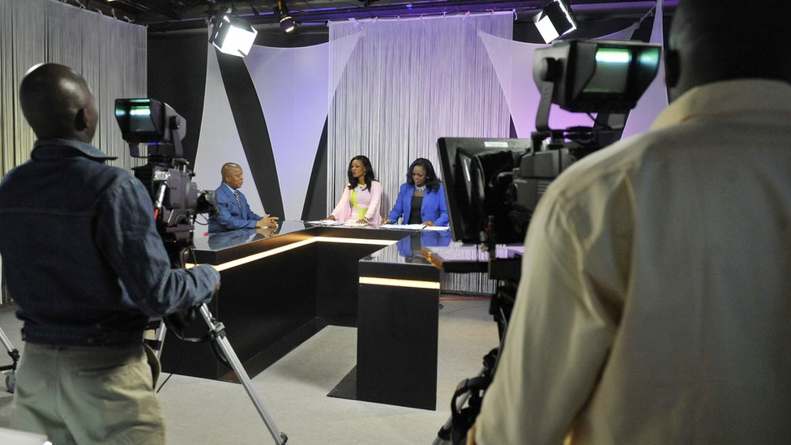image copyrightGetty Images

image captionIvory Coast public television studio

The government operates the outlets with the widest reach, including TV and radio networks and the main daily newspaper.

There are no privately-owned terrestrial TV stations.

The media are kept under close government scrutiny, says Reporters Without Borders.

# Ivory Coast profile - Timeline

Published

15 January 2019

## A chronology of key events

**1842** - France imposes protectorate over coastal zone.

**1893** - Ivory Coast made into a colony.

**1904** - Ivory Coast becomes part of the French Federation of West Africa.

**1944** - Felix Houphouet-Boigny, who later to become Ivory Coast's first president, founds a union of African farmers, which develops into the inter-territorial African Democratic Rally and its Ivorian section, the Ivory Coast Democratic Party.

**1958** - Ivory Coast becomes a republic within the French Community.

## Independence

**1960** - France grants independence under President Felix Houphouet-Boigny. He holds power until he dies in 1993.

**1990** - Opposition parties legalised; Houphouet-Boigny wins Ivory Coast's first multiparty presidential election, beating Laurent Gbagbo of the Ivorian Popular Front.

**1993** - Henri Konan Bedie becomes president following the death of Houphouet-Boigny.

**1995** October - Mr Bedie is re-elected in a ballot that is boycotted by opposition parties in protest at restrictions imposed on their candidates.

**1999** July - Alassane Ouattara, a Muslim, leaves job at International Monetary Fund and returns to run for president in 2000; his plan to challenge Bedie splits country along ethnic and religious lines.

## Coup

**1999** December - President Bedie is overthrown in military coup, replaced by General Robert Guei.

**2000** October - General Guei proclaims himself president after announcing he has won presidential elections, but is forced to flee in the wake of a popular uprising and is replaced by his challenger Laurent Gbagbo.

Fighting erupts between President Gbagbo's mainly southern Christian supporters and followers of his main opponent Alessandre Ouattara, who are mostly Muslims from the north.

**2001** March - President Gbagbo and Mr Ouattara meet and agree to work towards reconciliation.

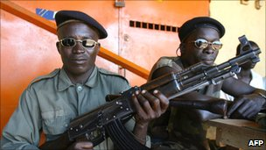image copyrightAFP

image captionThe 2002-3 civil war left Ivory Coast divided for several years

**2002** August - Ouattara's RDR party given four ministerial posts in new government.

## Rebellion

**2002** September - Mutiny in Abidjan by soldiers unhappy at being demobilised grows into full-scale rebellion, with Ivory Coast Patriotic Movement rebels seizing control of the north.

**2003** March - Political parties, rebels agree on new government to include nine members from rebel ranks. Consensus prime minister, Seydou Diarra, is tasked with forming cabinet.

## UN deploys

**2004** March - Deadly clashes during crackdown on opposition rally against President Gbagbo in Abidjan. First contingent of UN peacekeeping force deployed.

**2004** November - Ivorian air force attacks rebels; French forces enter the fray after nine of their soldiers are killed in an air strike. Violent anti-French protests ensue. UN imposes arms embargo.

**2005** April **-** After talks in South Africa the government and rebels declare an "immediate and final end" to hostilities.

**2005** June - Massacres in western town of Duekoue: President Gbagbo says more than 100 people were killed, but contradicts widely-held view that ethnic rifts lay behind violence.

**2005** October - Planned elections are shelved as President Gbagbo invokes a law which he says allows him to stay in power. The UN extends his mandate for a further year.

**2006** September - Government resigns over a scandal involving the dumping of toxic waste in Abidjan. Fumes from the waste kill three people and make many more ill.

## Power-sharing deal

**2007** March - Government and New Forces rebels sign a power-sharing peace deal, mediated by Burkina Faso. Under the deal, New Forces leader Guillaume Soro is named prime minister.

**2007** December - Rebel, government soldiers pull back from front-line positions as part of process to reunite country.

**2008** April - President Gbagbo cancels custom duties after a second day of violent protests against rising food costs.

**2009** May - Former rebels hand over 10 northern zones to civilian administrators, as part of the process of returning the northern part of the country to state control.

**President Ouattara takes over**

**2010** December - Election commission declares Mr Ouattara the winner of presidential election run-off. Mr Gbagbo refuses to accept result, and dispute between the two camps soon escalates into violence.

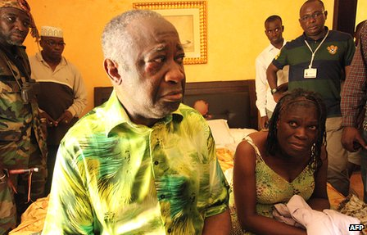image copyrightAFP

image captionImages of Laurent Gagbo's capture went around the world April 2011

**2011** April - Alassane Ouattara's forces capture Laurent Gbagbo, who is handed over to the International Criminal Court in The Hague in November to face charges of crimes against humanity.

**2011** September - Truth, Reconciliation and Dialogue Commission - aimed at forging unity after post-election violence that left about 3,000 people dead and 500,000 displaced - is launched.

**2011** December - Parliamentary elections. President Ouattara and his allies secure a majority. Followers of Laurent Gbagbo boycott the vote.

**2014** April - UN Security Council lifts embargo on Ivory Coast's diamond trade.

**Al-Qaeda attacks**

**2016** March - Al-Qaeda jihadists attack the beach resort of Grand Bassam, near Abidjan, killing 18 people. The attack follows similar assaults on hotels in the capitals of Mali and Burkina Faso in recent months.

**2017** January - President Ouattara sacks army, policy and gendarmes chiefs over two-day army mutiny in various cities, which ended when government paid bonuses and pledged to improve working conditions.

**2017** January-May - Sporadic mutinies by soldiers over non-payment of bonuses.

**2017** September - An environmental group says the chocolate industry is causing massive illegal deforestation, fuelling a catastrophic decline in wildlife.

**2018** August - Former first lady Simone Gbagbo is amnestied in what President Ouattara says is a move to foster reconciliation.

**2019** January - The International Criminal Court acquits Ivory Coast ex-president Laurent Gbagbo of charges of crimes against humanity over violence following the 2010 election.